Project

Topic: Host a static website using amazon s3.

Why S3:

1. Cost-Effective

Pay-As-You-Go Pricing: Amazon S3 charges based on the amount of data stored and the data transfer used, which can be very cost-effective for static websites that don’t require extensive backend infrastructure.

No Server Management: Since you don't need to manage servers, you save on costs related to server maintenance and uptime.

2. Scalability

Automatic Scaling: S3 automatically scales to handle the traffic demands of your website, whether it’s a small site with minimal traffic or a high-traffic website with thousands of requests per second.

High Availability: S3 is designed for 99.999999999% durability and 99.99% availability of objects over a given year.

3. Performance

Low Latency: S3 serves content from edge locations using Amazon CloudFront (when configured), reducing latency and improving load times for users globally.

Global Reach: S3 is available in multiple AWS regions, ensuring your content can be delivered quickly to users worldwide.

4. Simplicity and Ease of Use

Simple Management: With a straightforward web-based interface, managing your files and configuring your website is easy.

Integration with Other AWS Services: S3 integrates seamlessly with other AWS services like CloudFront for CDN, Route 53 for DNS, and Lambda for serverless functions, enhancing the capabilities of your static website.

5. Security

Fine-Grained Access Control: S3 provides comprehensive security and compliance capabilities, including bucket policies, access control lists (ACLs), and AWS Identity and Access Management (IAM) roles.

Encryption: Data can be encrypted at rest using S3-managed keys (SSE-S3), AWS KMS-managed keys (SSE-KMS), or customer-provided keys (SSE-C).

6. Reliability

Durability and Redundancy: Data stored in S3 is automatically replicated across multiple facilities and devices within an AWS Region, ensuring high durability and availability.

Backup and Versioning: S3 offers versioning, which keeps multiple versions of an object in the same bucket, enabling easy data recovery and rollback.

7. Flexibility

Static Content Hosting: Ideal for static content such as HTML, CSS, JavaScript, images, videos, and documents.

Static Website Features: S3 supports advanced features like redirects, error pages, and index documents, allowing you to create a fully functional static website.

Steps to follow:

Step 1: Create an S3 Bucket

1)Log in to AWS Management Console:

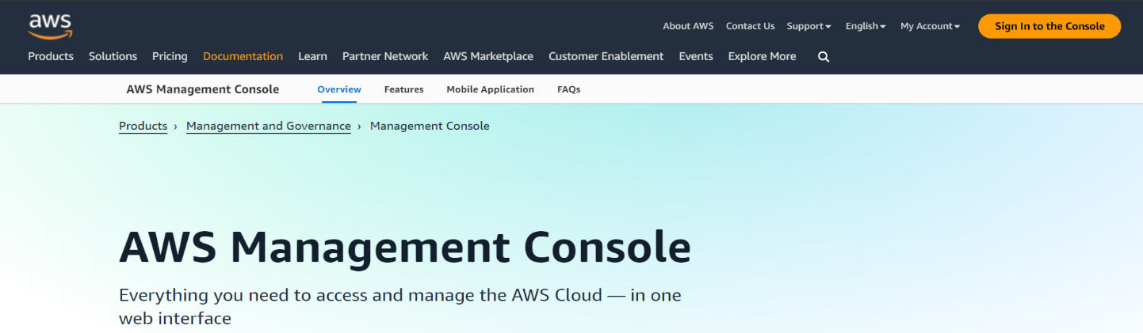

2)Go to the AWS Management Console.

2)Navigate to S3:

1)Select “S3” from the “Services” menu.

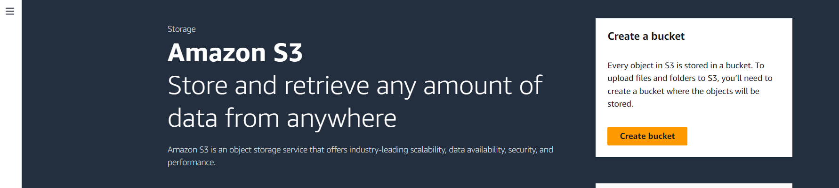

2)Create a New Bucket:

3)Click on the “Create bucket” button.

4)Enter a unique bucket name. The bucket name must be globally unique and follow DNS naming conventions (e.g., example.com).

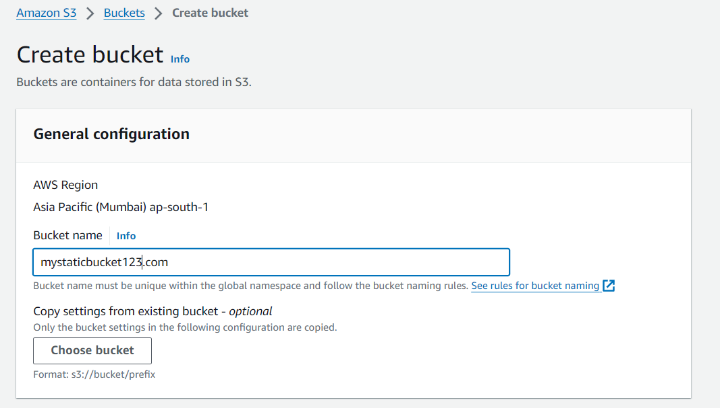

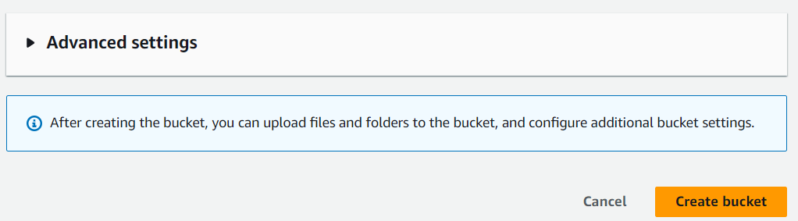

5)Click "Create bucket" after configuring additional settings if necessary.

Step 2: Configure the Bucket for Static Website Hosting

1)Select Your Bucket:

2)Click on the bucket you created.

3)Enable Static Website Hosting:

4)Go to the “Properties” tab.

5)Click on “Static website hosting”.

6)Choose “Use this bucket to host a website”.

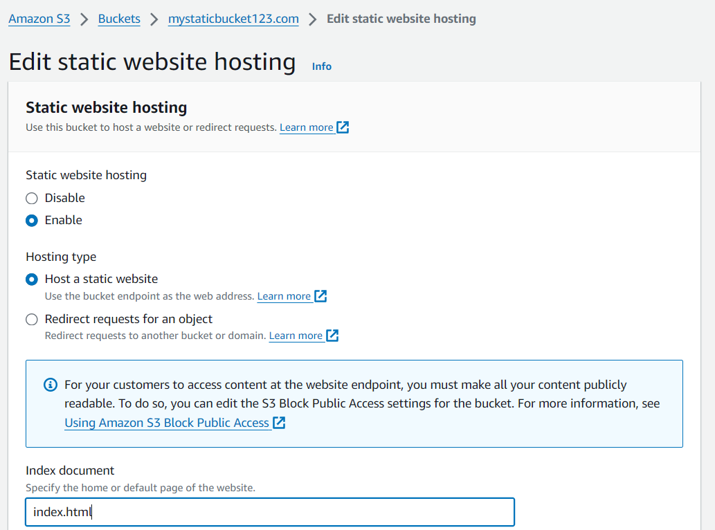

7)Specify the index document (e.g., index.html).

8)Optionally, specify an error document (e.g., error.html).

9)Save changes.

Step 3: Upload Your Website Files

1)Upload Files:

2)Go to the “Objects” tab within your bucket.

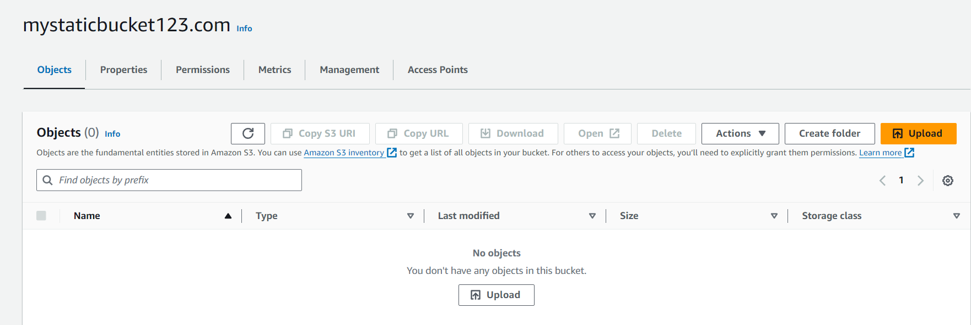

3)Click the “Upload” button.

4)Drag and drop your website files or browse to select them.

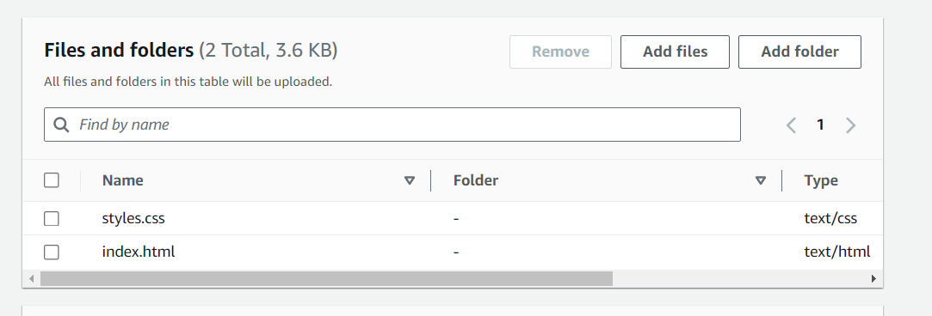

5)Click “Upload” to add them to your bucket.

Step 4: Set Permissions

1)Make Your Bucket Public:

2)Go to the “Permissions” tab.

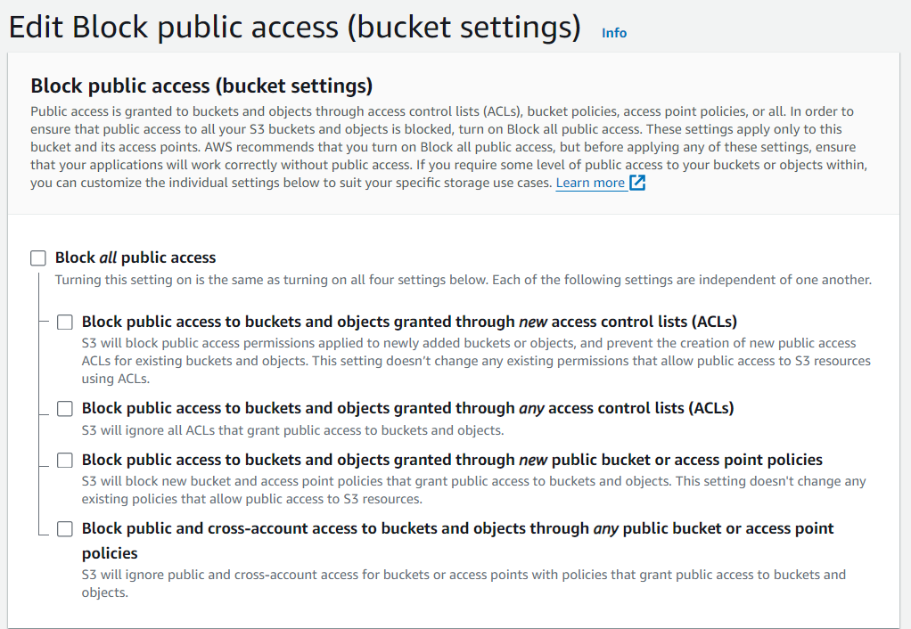

3)Disable Block public access.

4)Click on “Bucket Policy”.

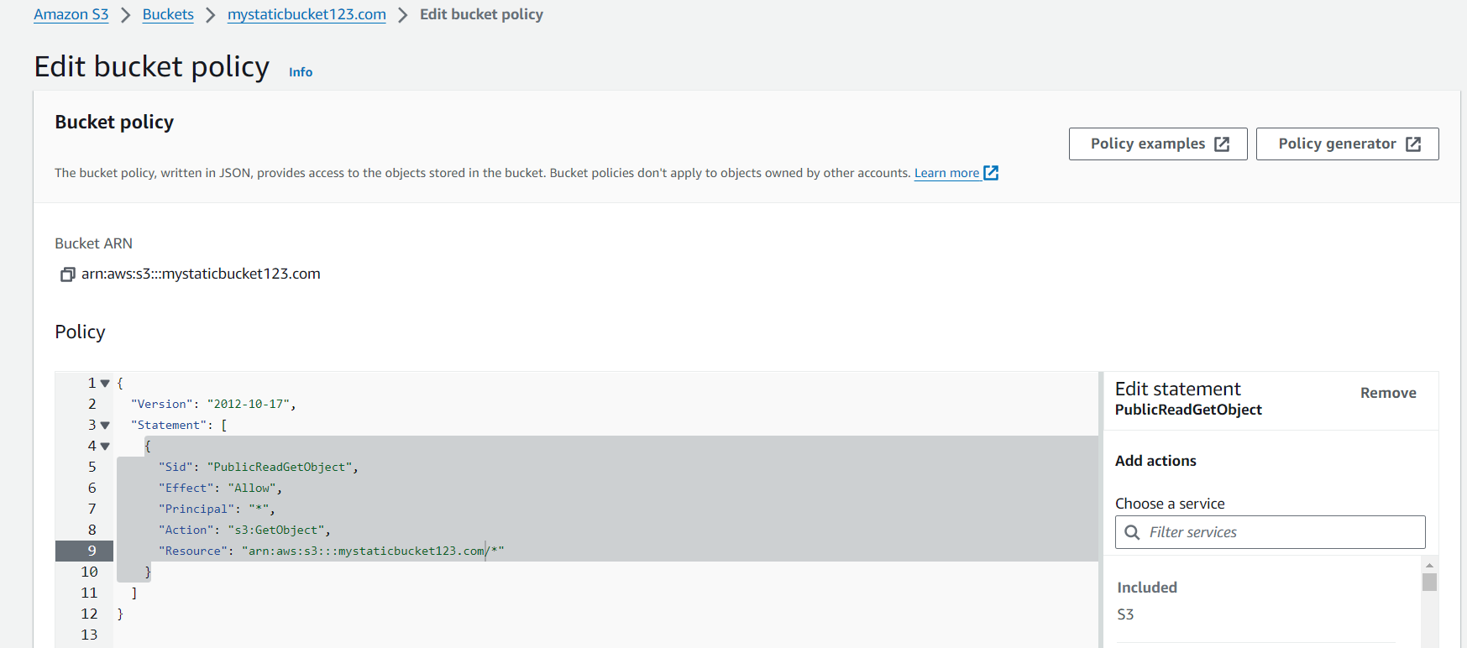

5)Add a bucket policy to make the content publicly accessible. Here’s a sample policy you can use:

JSON:

{

"Version": "2012-10-17",

"Statement": [

{

"Sid": "PublicReadGetObject",

"Effect": "Allow",

"Principal": "\*",

"Action": "s3:GetObject",

"Resource": " arn:aws:s3:::mystaticbucket123.com/\*"

}

]

}

6)Replace your-bucket-name with the name of your S3 bucket.

7)Click “Save”.

Step 5: Access Your Website

1)Find the Website URL:

2)Go to the “Properties” tab.

3)Click on “Static website hosting”.

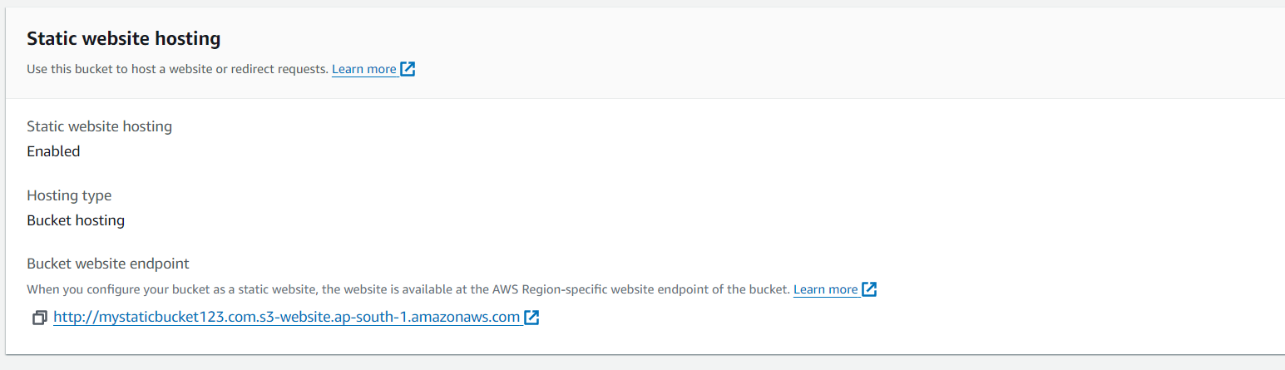

4)Your website endpoint URL will be displayed. It will look something like <http://your-bucket-name.s3-website-region.amazonaws.com>.

5)Paste the URL into a new window & it should look like this,

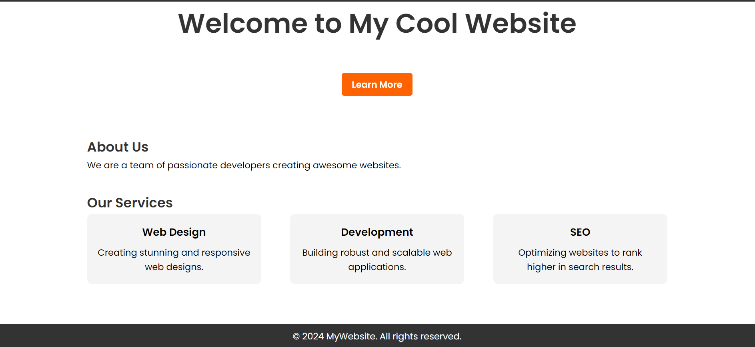

Summary

By following these steps, you can host a static website using Amazon S3. This setup is cost-effective, scalable, and easy to maintain.

Optional: Use a Custom Domain with Route 53

Step1: Register a Domain:

1)If you don’t have a domain, you can register one via Route 53 or any other domain registrar.

2)Create a Hosted Zone in Route 53:

Step2: Go to the Route 53 console.

1)Click “Create Hosted Zone”.

2)Enter your domain name and click “Create”.

Step 3: Set Up Alias Record:

1)In the hosted zone, click “Create Record Set”.

2)Select “Alias” as the record type.

3)Enter the name (e.g., www for www.your-domain.com).

4)Choose the S3 website endpoint as the Alias Target.

5)Save the record set.

Note: Delete all the resources created if not needed for further use.